LAB EXPERIMENT RECORD

Set 7: Customer Demographics Analysis

Department | AI&DS
Course Code / Course Name | DSA0602 / Data Handling and Visualization
Experiment | Data Visualization using R
Name | P.Mohith Kumar Reddy
Register Number | 192524223
Date | 3 October 2026
Day | Saturday

Aim
To visualize customer demographic data using a bar chart, pie chart, and data table in R, and to build an interactive dashboard in Tableau.

Dataset: Customer Demographics

Customer ID | Age | Gender | Income (in $)
1 | 28 | Female | 50000
2 | 35 | Male | 60000
3 | 42 | Female | 75000

OGRAM 1: Bar Chart of Customer Ages
Create a bar chart to visualize the distribution of customer ages. Label the axes and title the chart.
# Dataset
customer_id <- c(1, 2, 3)
age <- c(28, 35, 42)

# Bar Chart barplot(age,
names.arg = customer_id, xlab = "Customer ID", ylab = "Age (years)",
main = "Distribution of Customer Ages", col = "skyblue",
ylim = c(0, 50))
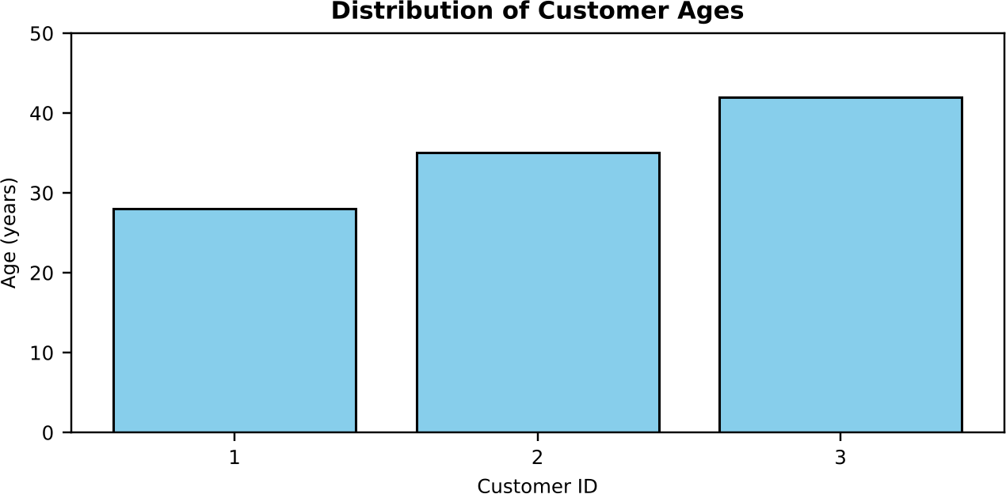

Output 1: Distribution of Customer Ages Bar Chart
Observation: Customer 3 is the oldest (42 years) and Customer 1 is the youngest (28 years). Customer 2 is 35 years old, so the ages increase steadily with the customer ID and the average age is 35 years.

PROGRAM 2: Pie Chart of Customers by Gender
Generate a pie chart to represent the distribution of customers by gender.
# Dataset
gender <- c("Female", "Male", "Female")

# Count and percentage of each gender gender_count <- table(gender)
percent <- round(gender_count / sum(gender_count) * 100, 1) labels <- paste0(names(gender_count), " (", percent, "%)")

# Pie Chart pie(gender_count,
labels = labels,
col = c("pink", "skyblue"),
main = "Distribution of Customers by Gender")
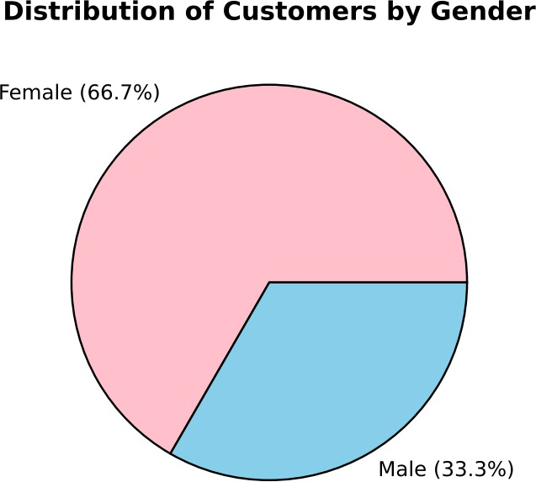

Output 2: Distribution of Customers by Gender (Pie Chart)
Observation: Female customers form the larger share with 2 of the 3 customers (66.7%), while male customers make up the remaining 1 customer (33.3%).

PROGRAM 3: Table of Demographic Information
Build a table to show the demographic information for each customer. Label the table elements.
# Dataset
customers <- data.frame( Customer_ID = c(1, 2, 3),
Age = c(28, 35, 42),
Gender = c("Female", "Male", "Female"), Income = c(50000, 60000, 75000))

# Label the table elements
colnames(customers) <- c("Customer ID", "Age", "Gender", "Income (in $)")

# Display the table print(customers)

# Average age and average income mean(customers$Age) mean(customers$Income)

Customer ID | Age | Gender | Income (in $)
1 | 28 | Female | 50000
2 | 35 | Male | 60000
3 | 42 | Female | 75000

Output 3: Customer Demographics Table
Observation: The table lists the age, gender, and income of each customer. The average age is 35 years and the average income is $61,666.67. Income rises with age: $50,000 at age 28, $60,000 at age 35, and $75,000 at age 42.

PROGRAM 4: Tableau Dashboard for Customer Demographics
Develop a Tableau dashboard combining the bar chart, pie chart, and table for interactive exploration of customer demographics.

Steps in Tableau:
- Save the customer data as an Excel or CSV file with the columns Customer ID, Age, Gender, and Income.
- Open Tableau, choose Connect > Microsoft Excel / Text file, and load the file. Right-click Customer ID and choose Convert to Dimension so that the IDs are not summed.
- Sheet 1 (Bar Chart): drag Customer ID to Columns and Age to Rows (SUM). Choose the Bar mark type and title the sheet "Customer Ages".
- Sheet 2 (Pie Chart): choose the Pie mark type, drag Gender to Color and Number of Records to Angle. Drag Number of Records to Label and apply Quick Table Calculation > Percent of Total. Title the sheet "Gender Distribution".
- Sheet 3 (Table): drag Customer ID and Gender to Rows, then drag Measure Names to Columns and Measure Values (Age, Income) to Text. Title the sheet "Customer Details".
- Create a new Dashboard, drag all three sheets onto it, and arrange the bar chart and pie chart at the top and the table at the bottom.
- For interactivity, select "Use as Filter" on the bar chart and pie chart and add a Gender filter (Show Filter), so that every view updates together.
- Title the dashboard "Customer Demographics Dashboard" and save the workbook.
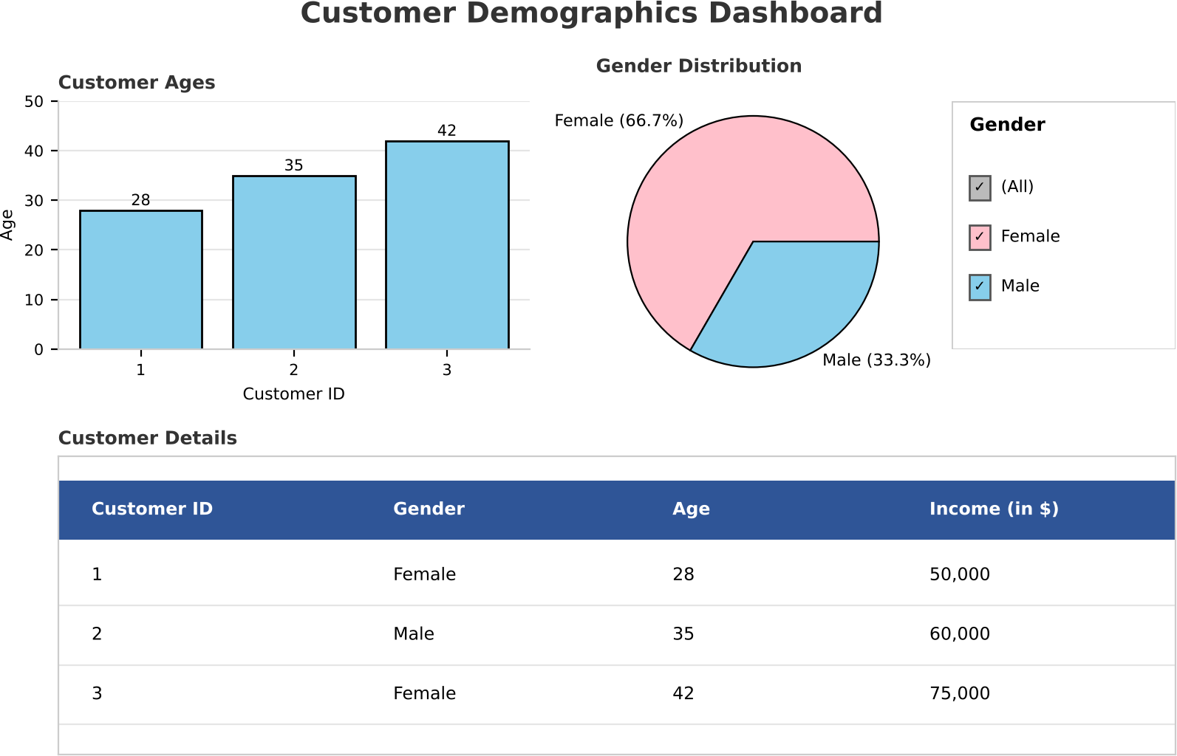

Output 4: Customer Demographics Tableau Dashboard
Observation: The dashboard shows the customer ages, the gender split, and the detailed table together. Clicking a bar, a pie slice, or the Gender filter updates all three views, so users can explore the demographics interactively.

Set 7 Procedure
- Create vectors for the customer ID, age, gender, and income.
- Use barplot() to display the age of each customer.
- Use table() to count the genders and pie() to draw the gender distribution.
- Build a data frame with data.frame(), label the columns with colnames(), and display it with print().
- Connect the dataset in Tableau, build the bar chart, pie chart, and table sheets, and combine them in a dashboard with filters.

Set 7 Result
The customer demographic data was successfully visualized using a bar chart, pie chart, and data table in R. A Tableau dashboard combining all three views was created for interactive exploration.

Key Functions Used

Function / Tool | Purpose
barplot() | Creates the bar chart of customer ages.
table() | Counts the customers in each gender.
pie() | Creates the pie chart of the gender distribution.
data.frame() / print() | Builds and displays the demographic table.
Tableau Dashboard | Combines sheets with filters for interactive exploration.

